Jason Holman and Boden Archuleta Iteration 1 Database Design

1. 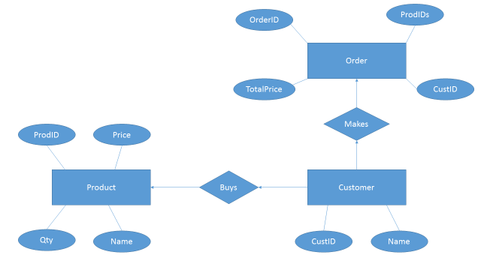

2. Product

|  |  |  |  |
| --- | --- | --- | --- |
| **ProdID(key)** | **Name** | **Price** | **Qty** |
| 100 | Apple | 1.99 | 5 |
| 101 | Orange | 2.50 | 7 |

Customer

|  |  |
| --- | --- |
| **CustID(key)** | **Name** |
| 1000 | John Smith |
| 1001 | Jane Doe |

Order

|  |  |  |  |
| --- | --- | --- | --- |
| **OrderID(key)** | **CustID** | **ProdIDs** | **TotalPrice** |
| 900 | 1000 | ID[] | 50.24 |
| 901 | 1001 | ID[] | 47.98 |

Buys

|  |  |  |
| --- | --- | --- |
| **CustID(key)** | **ProdID(key)** | **Qty** |
| 1000 | 100 | 8 |
| 1001 | 101 | 9 |
| 1000 | 100 | 4 |

3. create table PRODUCT (

ProdID int not null primary key,

Name char(30) not null,

Price number not null,

Qty int not null);

create table CUSTOMER (

CustId int not null primary key,

Name char(30) not null);

create table ORDER (

OrderID int not null primary key,

CustID references CUSTOMER (CustID)

On delete cascade,

ProdIDs references BUYS (Qty) not null,

TotalPrice number not null,

create table BUYS (

CustID references CUSTOMER (CustID)

On delete cascade,

ProdID references PRODUCT (ProdID)

On delete cascade,

Qty int not null,

primary key (CustID, ProdID));